Politecnico di Torino

Master Degree in Artificial Intelligence and Data Analytics

Machine Learning and Pattern Recognition
Prof. Sandro Cumani


Fingerprint Spoofing
February 1, 2024
Roberto Gaetano, s318989
Distefano Giuseppe, s309787

1 Introduction

1.1 Abstract
___

1.2 Problem overview
___

1.3 Feature analysis
___
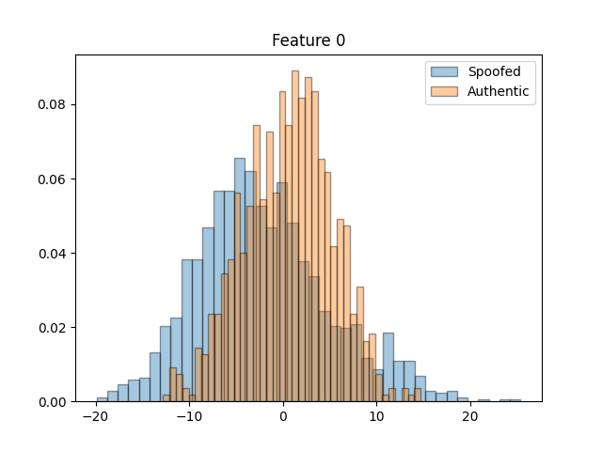 | 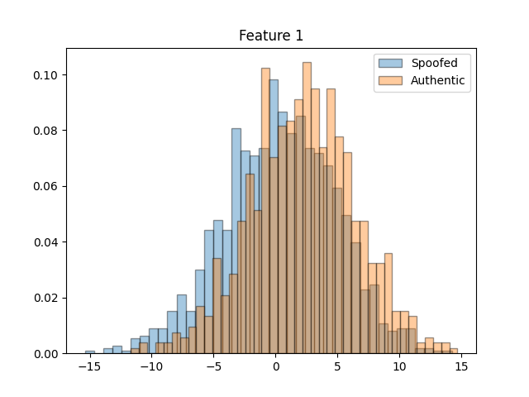 | 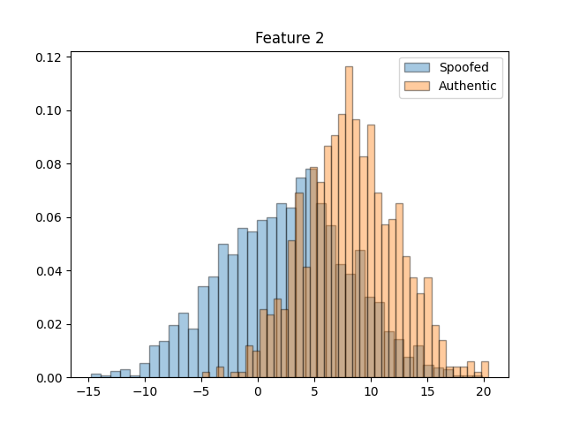
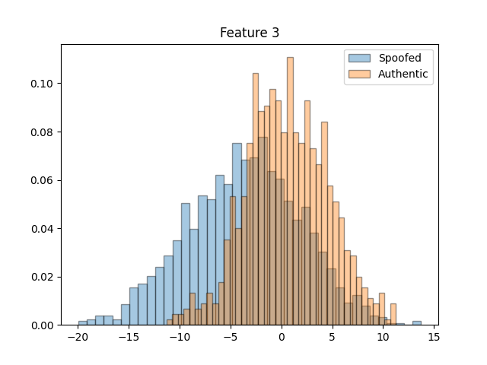 | 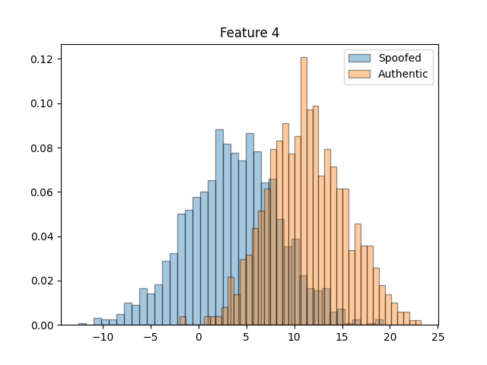 | 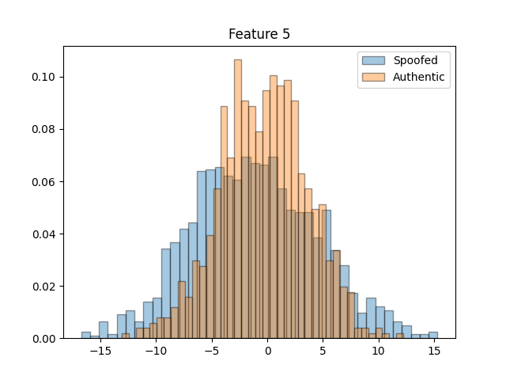
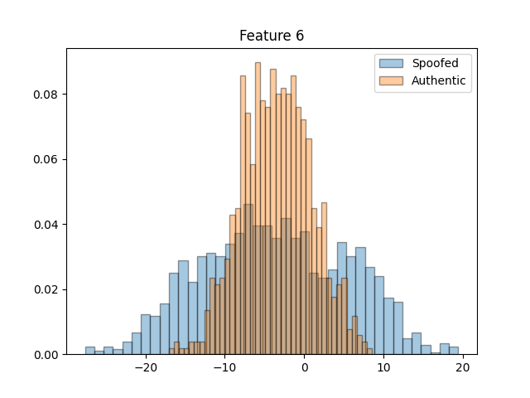 | 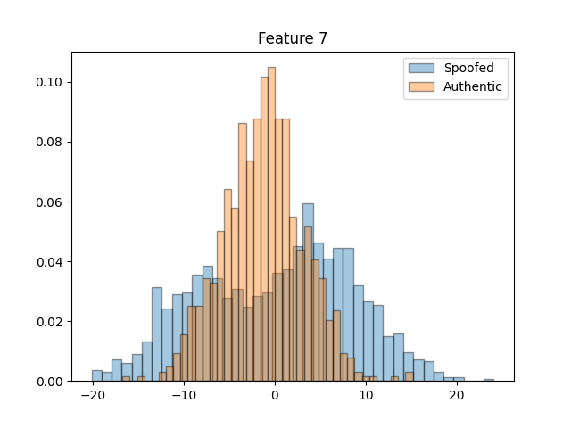 | 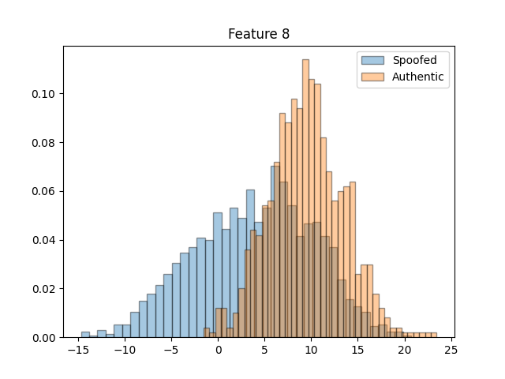
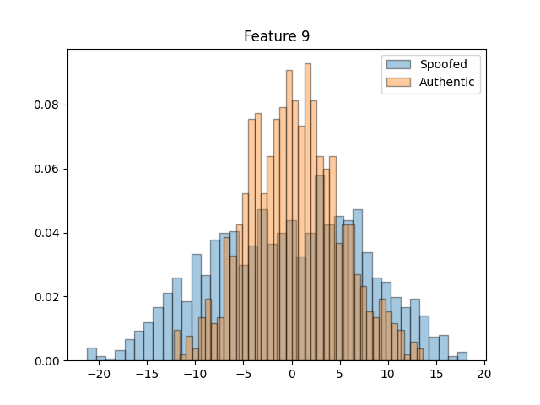
Figure 1: Histograms of features
___
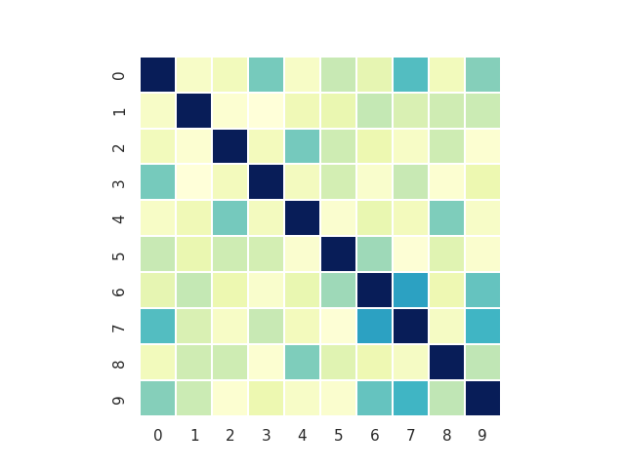 | 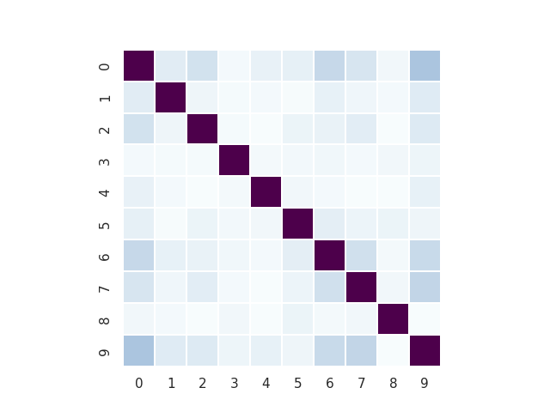 | 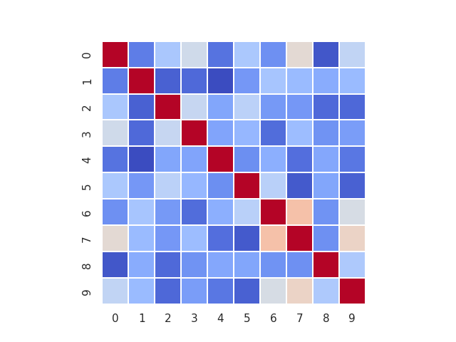
Figure 2: Heatmaps
___
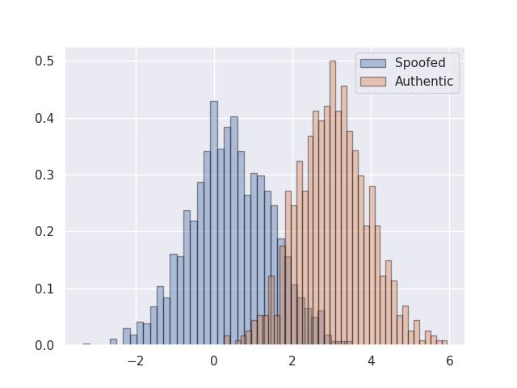
Figure 3: LDA
___
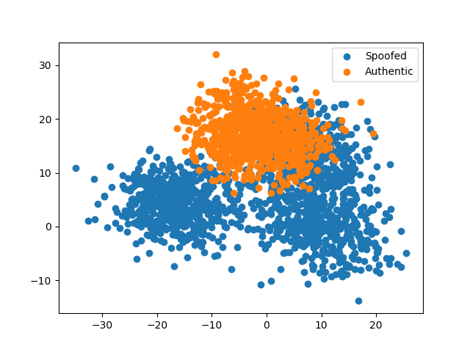
Figure 4: Scatter plot of all features
___

1.4 Training
___

2 Gaussian Classifiers
___

2.1 Objective function
___

2.2 Expectations
___

2.3 Results
___
MVG Classifier
PCA | minDCF, π = 0.1 | minDCF, π = 0.5 | minDCF, π = 0.9
- | 0.000 | 0.000 | 0.000
9 | 0.000 | 0.000 | 0.000
8 | 0.000 | 0.000 | 0.000
7 | 0.000 | 0.000 | 0.000
6 | 0.000 | 0.000 | 0.000
5 | 0.000 | 0.000 | 0.000

Naive Bayes Classifier
PCA | minDCF, π = 0.1 | minDCF, π = 0.5 | minDCF, π = 0.9
- | 0.000 | 0.000 | 0.000
9 | 0.000 | 0.000 | 0.000
8 | 0.000 | 0.000 | 0.000
7 | 0.000 | 0.000 | 0.000
6 | 0.000 | 0.000 | 0.000
5 | 0.000 | 0.000 | 0.000

MVG Classifier with tied covariance
PCA | minDCF, π = 0.1 | minDCF, π = 0.5 | minDCF, π = 0.9
- | 0.000 | 0.000 | 0.000
9 | 0.000 | 0.000 | 0.000
8 | 0.000 | 0.000 | 0.000
7 | 0.000 | 0.000 | 0.000
6 | 0.000 | 0.000 | 0.000
5 | 0.000 | 0.000 | 0.000

Naive Bayes Classifier with tied covariance
PCA | minDCF, π = 0.1 | minDCF, π = 0.5 | minDCF, π = 0.9
- | 0.000 | 0.000 | 0.000
9 | 0.000 | 0.000 | 0.000
8 | 0.000 | 0.000 | 0.000
7 | 0.000 | 0.000 | 0.000
6 | 0.000 | 0.000 | 0.000
5 | 0.000 | 0.000 | 0.000
___

3 Logistic regression

3.1 Objective function
___

3.2 Expectations
___

3.3 Results

3.3.1 Linear logistic regression
___

3.3.2 Quadratic logistic regression
___

3.4 Conclusions
___

